1. Zapoznaj się ze słówkami i wydrukuj flashcards.
Rabbit/ bunny- królik
nose- nos
ears- uszy
tail- ogon

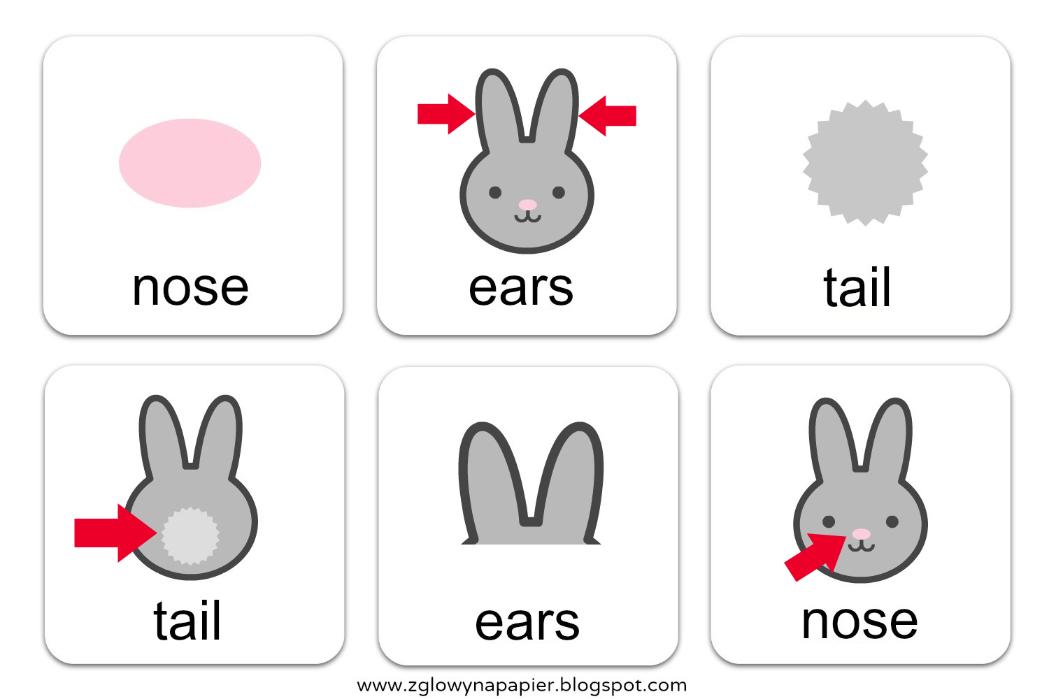
2. ’’What’s missing?’’.
Rodzic rozkłada karty (flashcards) i przedstawia każde ze słówek w języku angielskim a dziecko powtarza. Następnie rodzic prosi aby dziecko zamknęło oczy ”Close your eyes” (Dziecko zamyka oczy). Rodzic zasłania jedną z kart i mówi ”Now open your eyes and tell me: What’s missing? (Teraz otwórz oczy i powiedz czego brakuje w języku angielskim). Dziecko zgaduje czego brakuje. Gramy do momentu aż dziecko odgadnie wszystkie karty.
3. Zapoznaj się z treścią piosenki .
There is a rabbit with a pink nose,
floppy ears and a fluffy tail
and Bunny is his name-O
B-U-N-N-Y
B-U-N-N-Y
B-U-N-N-Y
and bunny is his name-o
There is a rabbit with a pink nose,
floppy ears and a fluffy tail
and Bunny is his name-O
(clap) U-N-N-Y
(clap) U-N-N-Y
(clap) U-N-N-Y
and bunny is his name-o
There is a rabbit with a pink nose,
floppy ears and a fluffy tail
and Bunny is his name-O
(clap) (clap) N-N-Y
(clap) (clap) N-N-Y
(clap) (clap) N-N-Y
and bunny is his name-o
There is a rabbit with a pink nose,
floppy ears and a fluffy tail
and Bunny is his name-O
(clap) (clap) (clap) N-Y
(clap) (clap) (clap) N-Y
(clap) (clap) (clap) N-Y
and bunny is his name-o
There is a rabbit with a pink nose,
floppy ears and a fluffy tail
and Bunny is his name-O
(clap) (clap) (clap) (clap)-Y
(clap) (clap) (clap) (clap)-Y
(clap) (clap) (clap) (clap)-Y
and bunny is his name-o
There is a rabbit with a pink nose,
floppy ears and a fluffy tail
and Bunny is his name-O
(clap) (clap) (clap) (clap) (clap)
(clap) (clap) (clap) (clap) (clap)
(clap) (clap) (clap) (clap) (clap)
and bunny is his name-o

https://www.youtube.com/watch?v=nZLIiq7B85g

